MySQL Stored Procedures(Triggers & Events)

Reference: http://dev.mysql.com/doc/refman/5.1/en/create-trigger.html
CREATE TRIGGER trigger_name
trigger_time trigger_event
ON tbl_name FOR EACH ROW
trigger_body
trigger_time: { BEFORE | AFTER }
trigger_event: { INSERT | UPDATE | DELETE }
This statement creates a new trigger. A trigger is a named database object that is associated with a table, and that activates when a particular event occurs for the table.
Create trigger is a restricted (security controlled) SQL statement; I.e the user must be granted the privilege to execute this statement.
trigger_time is the trigger action time. It can be BEFORE or AFTER to indicate that the trigger activates before or after each row to be modified.
trigger_event indicates the kind of statement that activates the trigger. The trigger_event can be one of the following:
- INSERT: The trigger is activated whenever a new row is inserted into the table;
- UPDATE: The trigger is activated whenever a row is modified;
- DELETE: The trigger is activated whenever a row is deleted from the table
It is important to understand that the trigger_event does not represent a literal type of SQL statement that activates the trigger so much as it represents a type of table operation. For example, an INSERT trigger is activated by not only INSERT statements but also LOAD DATA statements because both statements insert rows into a table.
There cannot be two triggers for a given table that have the same trigger action time and event. But e.g. you can have a BEFORE UPDATE and AFTER UPDATE on the same table.
trigger_stmt is the statement to execute when the trigger activates. If you want to execute multiple statements, use the BEGIN ... END compound statement construct. This also enables you to use the same statements that are allowable within stored routines. Some statements are not allowed in triggers; (check the Database reference manuals).
SQL is non procedural, but in some DBMS work we want to be able to do some procedural programming. Triggers, Events, Stored Routines, Stored procedures are all extensions to SQL to allow some procedural programming.
NB: the operation that fires the trigger WILL go ahead; the trigger cannot prevent that executing.
http://www.databasedesign-resource.com/mysql-triggers.html
Simply put, triggers are small programs that are stored in the database itself, and are activated by database events which often originate at the application layer. These precipitating database events are UPDATE, DELETE or INSERT queries. The trigger itself may execute before or after the query that initiates it.
Triggers are often used to maintain the integrity of data across tables of an application. When a user on a website makes a purchase, for example, the first action that occurs in the database may be that a credit is inserted into an accounting table.
By way of a trigger this action could initiate a chain reaction of events in other tables throughout the application. The product count of an item could be decremented in an inventory table, a debit deducted from a customer's account balance in another table, a store credit applied to yet another table.
To demonstrate how MySQL triggers work, let's set up two simple tables on a database we'll call “sales_records” that have data that is interdependent.
Imagine a database that tracks the sales records of three salespeople at a department store. They work in the electronics department selling things like TVs , stereos, and MP3 players.
We have the main table that keeps a record of each sale made. It records the amount of the sale (sale_amt), the date (date), the name of the salesman (name), his id number (employee_id), and the product id (prod_id). We'll call this table “sales”.
In the second table, we want to keep some data that will allow us to easily keep track of how each salesperson is doing. It will include the salesperson's id (employee_id), name (name), total number of sales (total_sales), and a column that keeps each salesperson's average amount per sale (ave_sale). We want to see who's moving the high-end items. We'll call this table “performance”.
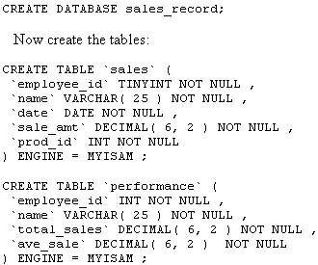
Triggers are database objects just as tables are. Triggers, however, are able to execute procedural code that modifies data in your tables. In this case, we want our trigger to fire before any INSERT statement that executes in the sales table. When a sale record is inserted in the sales table, the salesperson's totals must be updated in the performance table.
Our procedural code uses semicolons at the end of statements, so we need to set a different delimiter to let MySQL know when our code block is over, and so that it doesn't stop processing our block when it hits a semicolon. Keep in mind that after you finish your block you will have to reset the delimiter back to the semicolon, or end any subsequent commands with the new delimiter. For example if you made errors in your CREATE TRIGGER block and want to delete it, DROP TRIGGER; won't work unless you set the delimiter back to the semicolon.
The following code for the trigger can be typed and run as normal SQL . Before you do that though, you want to execute this line:
Delimiter $$ Note: the new delimiter can be any symbol
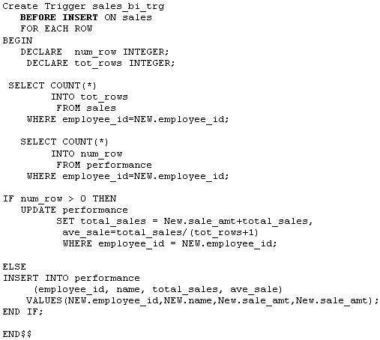
Delimiter ; NB: reset the delimiter back to ‘;’
Using the CREATE TRIGGER statement, we've initiated the trigger, naming it 'sales_bi_trg'. MySQL triggers can fire (execute) before or after an INSERT, UPDATE or DELETE event. This one fires before any data is inserted in the 'sales' table.
The FOR EACH ROW clause signifies that the block will act on each row that meets the criteria of our SQL statements. The keywords BEGIN and END enclose the trigger statements that will execute when the trigger fires.
There are two variables declared. The first is 'num_row' which checks to see if the employee has who has made the sale that is to be entered, has had a sale entered in the performance table previously. If there are no employee_id's that match, then this is the employee's first sale, and this meets the 'ELSE' condition of our “IF' statement.
This data will be entered as an insert in the performance table rather than an update. If the 'num_row' is greater than 0, then the performance table will be updated. The second variable, 'tot_rows', is a count of how many sales the employee has in the 'sales' table.
This value is used to calculate the employee's average sale. The count is being done before the sale is inserted in the sale table, so we have to add one to it. When the 'performance' table is updated the average sale = total_sales/(tot_rows+1).
If our MySQL trigger is working correctly, the 'performance' table will keep a running total of each salespersons total sales, and also the average amount of their total sales. It will do this independently of your application code and be portable to any application platform.
To test this in the lab, insert some data into the 'sales' table and monitor the content of the 'performance' table. Here is the statement:
Change the numbers and names and try it a few times. (Remember, an employee keeps the same employee_id number for each of his sales.) Reference: http://www.sqlteam.com/article/an-introduction-to-triggers-part-i
Other examples/exercises:
Create a logfile-table (Optype varchar 10, Ordtime Timestamp) to track user activity on an Orders table (Product varchar(10), Qty Int). Write a trigger so that each insert into Orders triggers an insert into the logfile table. The trigger code inserts the system date/time and operation desc e.g. Insert (‘Insert’,now()); Now() is a MySQL function that accesses the system clock for current date&time.
Expand this for Insert/update/delete. So, the table will remain small as inserts, updates and deletes proceed, but the log file table will keep growing as ins/upd/del proceed.
You can refer to columns in the subject table (the table associated with the trigger) by using the aliases OLD and NEW. OLD.col_name refers to a column of an existing row before it is updated or deleted. NEW.col_name refers to the column of a new row to be inserted or an existing row after it is updated.
Just as you Create and Drop tables; so too with Triggers i.e. Drop Trigger trig_name
Note: An operation on one table can trigger any operation on a different table, i.e. an operation on a table that triggers a stored procedure cannot work back on itself.
MySQL Events
We will assume that the compound statements (stored procedure) found in MySql Triggers (i.e. after the Do) can be as complex in an Event compound statement i.e. local variables, if statement, multiple SQL statements.(see Triggers handout on Sales application).

Note that the delimiter will need to be set/and reset;
Begin…. End will be required to define the event body.

CREATE EVENT event_name
ON SCHEDULE schedule
[ON COMPLETION [NOT] PRESERVE]
DO event_body;

schedule:
AT timestamp [+ INTERVAL interval] ...
| EVERY interval
[STARTS timestamp [+ INTERVAL interval] ...]
[ENDS timestamp [+ INTERVAL interval] ...]

interval:
quantity {YEAR | QUARTER | MONTH | DAY | HOUR | MINUTE |
WEEK | SECOND | YEAR_MONTH | DAY_HOUR | DAY_MINUTE |
DAY_SECOND | HOUR_MINUTE | HOUR_SECOND | MINUTE_SECOND}
Quantity: integer
MySQL server installation may default to disabling events in the configuration. Events are controlled by the event scheduler. To check the status of the scheduler, enter the following
‘SHOW VARIABLES LIKE ‘event%’;
To enable the scheduler, enter the following in an SQL/Admin client to set the required environment.

SET GLOBAL event_scheduler = ON;

